MARLTON CHRISTIAN ACADEMY Preschool Summer Newsletter

625 E. Main St., Marlton, NJ 08053

856.596.5304

www.mcaschools.org

Dear Parents:

We hope that you are enjoying the start of Summer. Welcome to all our new and returning families!
This September, classes will start on Tuesday, Sept. 5, 2023, following Labor Day. We look forward to seeing all your faces again!

Office Summer Hours for paperwork drop off will be Mondays through Fridays 8:00am –5:00pm. (Closed on Aug. 28-29 for Staff Orientation). Please place your paperwork in the outside mailbox on the wall if the office is closed. We will resume regular office hours (7am to 6pm) on Tuesday, Sept. 5, 2023. Thank you.

Student Files: If you have not already done so, please bring by any missing forms as soon as you are able in order to help us complete your child’s file. If your child has any special needs, such as an EpiPen, diet restrictions, or medical concerns, please come in before September so that we are aware and can prepare to care for them accordingly.

Please see the enclosed Back to School half sheet for information on your child’s schedule and tuition. Please review this sheet. If any of the information is incorrect, call the office immediately so we can correct it. If you need to make any Fall schedule changes you may do so until August 11, 2023.

Fall Registration will be closed August 14 through September 1. After August 14, changes, additions, or deletions may be made, however, they will not be effective until September 18, 2023. There will be a $20.00 fee charged for changing your schedule after August 14. It is best to make schedule changes before August 14.

Tuition Schedule: Please make note that the first tuition payment is due on August 1, 2023.
All questions about tuition or any other accounting concerns can be brought to the attention of Jeanette Strand in Bookkeeping. Her hours are 9:30am to 6:00pm. Please direct your questions to jstrand@mcaschools.org.

Security Cards: Security cards will be available on Thursday Aug.31 through Friday, Sept. 1 between the hours of 8:30 AM to 1:00 PM or on your child’s first day of school. If you do not have a Security Card on your first day of school, you may pick up your card from the office area after you have dropped off your child in their classroom. Staff will be at the Elmwood Road entrance to give you access to the school.

On the first day of school (Sept. 5) you will bring your child in through the office entrance (west side or Elmwood Road side of the building) and sign in on the sign-in sheet. You will then be directed to your child’s classroom. In the classroom you will meet your child’s teacher, find their cubby, and receive their name tags.
A second mailing will be sent home in late August with your child’s Teacher and Classroom assignment.

We will hold our Back to School Night on Monday, Sept. 18, 2023 at 7:00pm.
This is a time for parents to learn about our policies and procedures as well as
meet your child’s teacher. You will enjoy hearing the teachers share their heart
and vision for your child in their classroom this year.

September will be “getting to know my friends and school” month. Our theme is “I Am Special - Created in God’s Image”, (Genesis 1:26-27). Children will learn how special and unique they are in God’s eyes. Time will be spent on getting to know one another and reinforcing safety rules. Show and Tell will begin the week of Sept. 13. Children will bring in something that starts with the letter of the week. Your child will grow in many other areas such as science, music, Bible knowledge, gross and fine motor skills, and language arts are incorporated into our daily curriculum. Social and emotional skill develop as he/she makes new friends and enjoys new challenges.

October we will be celebrating the harvest.
We will have a Fall Party at the end of the month.
See our school calendar on our website for more details.

Other Reminders:

- When Show and Tell begins your child may bring in one item a week to school for Show & Tell. Other than this, please do not bring toys or valuables into school. They may be lost or broken.

- Please label all items with your child’s name that are brought to school, e.g. lunch box, mittens, jackets, etc. If something is misplaced we will return it to your child’s cubby.

- Please bring all medications in their original packaging with the doctor’s directions to the main office. Medications should not go directly to the teacher or classroom.

- Birthdays are special and we celebrate your child’s special day. You may send in a special snack. Please ask the teacher how many children will be present and for allergy restrictions.

- Please notify us promptly of any changes in pertinent information you included in any of your admission forms. These include: change of address, telephone number or place of employment. Blank admission forms will be available the first week of school for this purpose.

- Sometimes little girls like to wear dresses to school. Please be aware that the students sit on the carpet during circle time and girls enjoy climbing on the playground equipment. Parents, it would be a great idea if you would put shorts under their dresses.

- For Full Day students: Please take note that Nap Time bedding has specific requirements to ensure the safest and sanitary standards possible for your children: Each child may have 1 crib sized fitted sheet, small light blanket and mini-pillow. All bedding must fit into a 3 gallon ziplock bag provided by MCA. Each item should be labeled with your child’s name as well as their name prominently written on the outside of the bag. We appreciate your help!

Our school year is from Sept. 5, 2023 to June 14, 2024. Classes start promptly at 9:00AM. We hope and pray that this will be a great year for your family. If you have any questions or concerns about your child or the program, please feel free to give me a call at 856.596.5304.

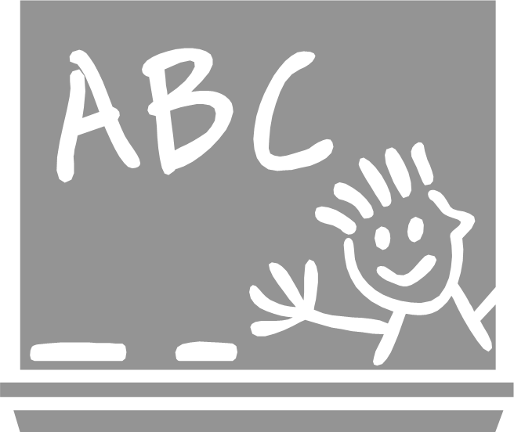
Looking forward to seeing you all soon,
Nona Eldabh
Preschool Director
Marlton Christian Academy

